We look at the program and it has 3 sections:

Random generation based license number then it prints the license number and then it generates a license code and prints the license code.

The part we are going to hack is

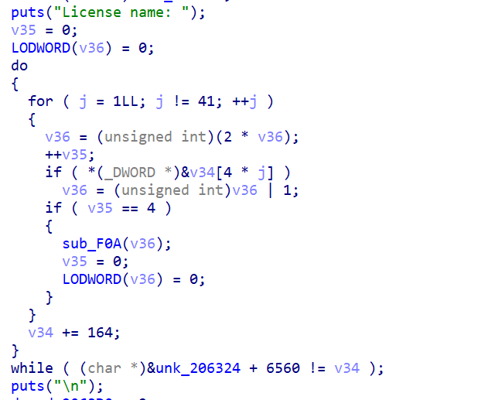

We will put our own license code here as if it was generated by the random generator. We only need to transform it into ones and zeroes as the program generates.

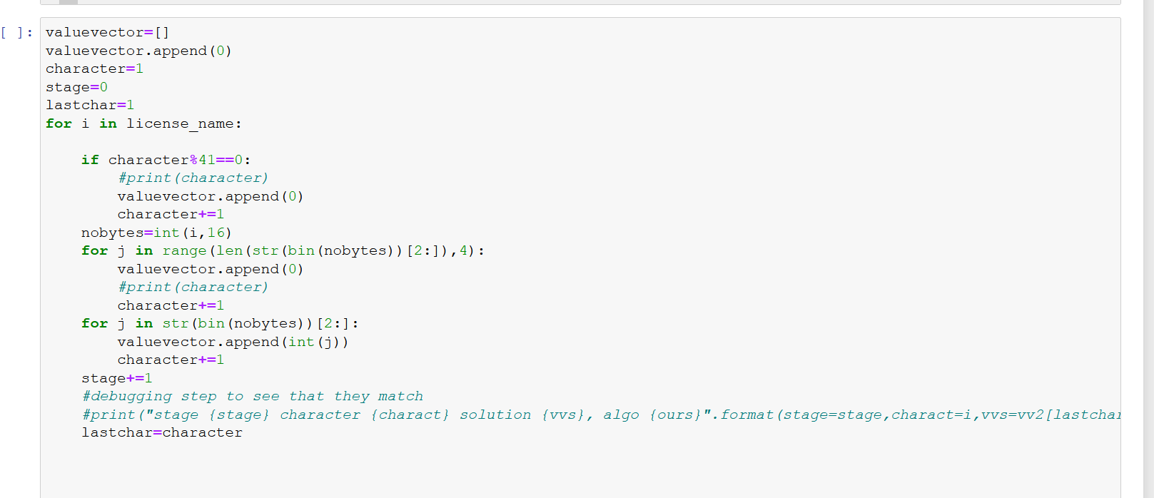

This python program transforms the license into the same format as the program needs.

Then we use ida python to patch the program and get the license code:

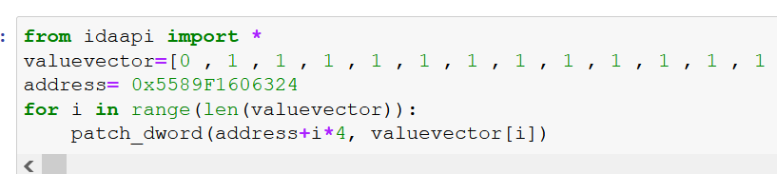

The address varies with every run so change it